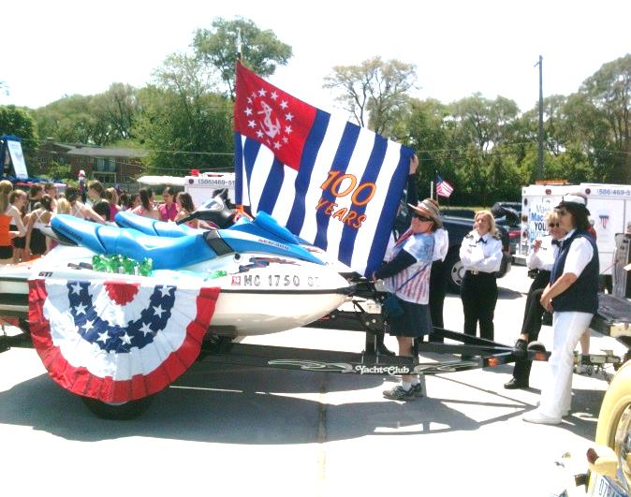
JOIN US IN HONORING OUR
VETERANS
AND
SUPPORTING
UNITED STATES POWER SQUADRON
Again this year D-9 Squadrons will be involved with the St. Clair Shores Memorial Day Parade, which is May 24th 2015 on Jefferson Ave this year. Not only are we supporting the USPS, but even more important is in HONORING OUR VETERIANS. This is known to be one of the largest Parades in Michigan.
We need your support!
Bonnie and Bob Krieg would like to invite anybody that walks in the Parade back over
to their house for lunch. Bring a dish to pass if you like and drinks you like.
Please RSVP so that we have plenty of food and seating!
586-943-1255 -22486 Ardmore Pk., St. Clair Shores
Line up at 9 mile Jefferson at 11:00 AM and step off time is 1:00PM.

