SHORE LINES

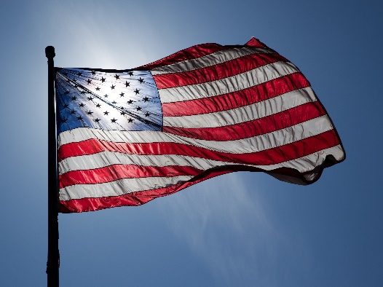

St. Clair Shores Sail and Power Squadron
May 2017 Newsletter

What’s Going On?

Meetings – May General Membership Meeting was held on Thursday, May 4th at the Grafton’s home. Meeting notes are available for anyone interested. Next General Membership meeting is 1 June, and is our annual picnic meeting at the Bruce Post. Flyer is attached, all are welcome. Hope to see you there.

Memorial Day – The 2017 St. Clair Shores Memorial Day Parade will be held on Sunday, May 28th. Step off time is 1:00 p.m. sharp with lineup beginning at 11:00 a.m. There is a party to follow for participants at the Krieg’s home. For information contact Bob Krieg at 586-943-1255.

Please see flyers below!

A Note From the Commander – Vivian Grafton
It has been such an eventful few weeks I am not sure where to begin. I think we will go back to Spring Conferences. Hospitality night was a lot of fun as usual and the rooms looked amazing. It is always nice to meet other boaters from around the state and discuss the adventures they have on the lakes and rivers in their regions. My favorites are always the fishing reports; I can never tell how tall the tale is. On Saturday during the awards presentation our squadron received a few awards. One of them was actually at a national level. Everyone should be very proud of these awards. I will have them on display at the picnic meeting in June. The members who attended the classes at the conference had wonderful feedback and over all the spring conference was very beneficial to our group this year.
Mike Boyle spent every Wednesday evening in March teaching the ABCs of boating class. Everyone should give Mike a big thank you for doing such a great job running and teaching this class. I look forward to the future of our education department. We also had three members attend this class; Michelle Belcher, Henry Belcher and Jackson Belcher so if you see them give them a pat on the back also.
The April and May meetings went extremely well. Thank you all who were able to attend. We have been talking a lot about membership and the picnic meeting on June 1st. It will be a membership drive meeting so I encourage everyone to tell your friends, and hopefully bring a friend or maybe even two friends. We will be looking for a head count in mid to late May for the hot dogs; it will still be bring a dish. Bonnie’s baskets will be raffled and of course 50/50. Matt Grafton at 586-709-0153 is the contact for this meeting. Watch your e-mails for more to come. I think this is a good spot to remind everyone that any potential members should be given an application and Andy Kay’s e-mail. His e-mail is on the new roster I sent out and we are trying to get everyone familiar with the USPS site to have the ability to print an application. We also started talking about ship store again. We are looking for someone to do our embroidering. The May meeting focused on VSCs and summer plans and trips. We are working hard to get calendars and flyers out to everyone with all of the SCSSPS events and District 9 events. Something I would like to make sure everyone is aware of is the SCS Memorial Day parade. This is supposed to be a fabulous time; Bob and Bonnie Krieg are the contacts for this event. Keep an eye on your e-mails for other events.
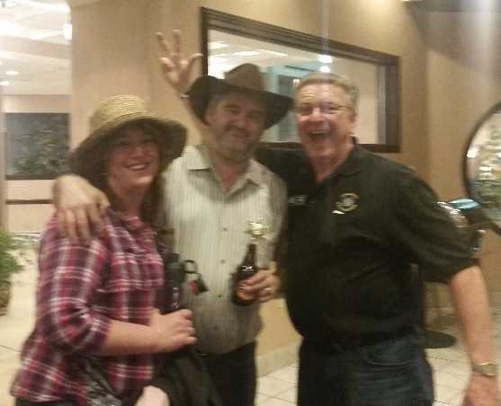
It is now time to talk about boats. All the hard water is gone, launch season is here. I would like to give everyone a few reminders. Before you make your first voyage across the lake, make sure your radio is working and someone knows your plan. It still gets very cold on the water and there are not very many boats out yet. Check your life jackets and safety equipment. Make sure you have plenty of time to enjoy that first boat trip of the year. Many small boats, paddle boarders, and kayaks are already in the water. If you’re planning to enjoy the day on one of these try to keep the rapidly changing Michigan weather in mind. Be prepared for drastic temperature changes and have the equipment needed to prevent hypothermia. Most importantly THINK SAFETY FIRST! I can’t wait to see everyone on June 1st for the next GM meeting and picnic!

Vivian and Matt Grafton
attending the hoe-down
themed Spring Conference

Schedule of Events
St. Clair Shores Memorial Day Parade – May 28

General Membership Meeting and Picnic – June 1

SCS Fireworks – June 24

MacRays – 4th of July

Frostbite – September 22-24

Spring Conference

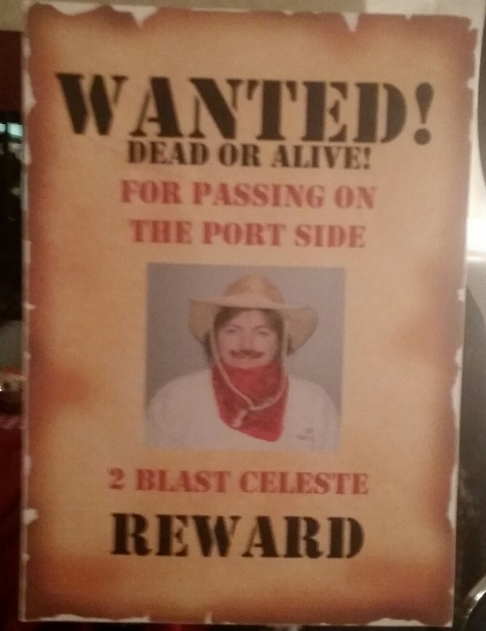
APRIL 2017
Concorde Inn
Clinton Township, MI

See below for D9
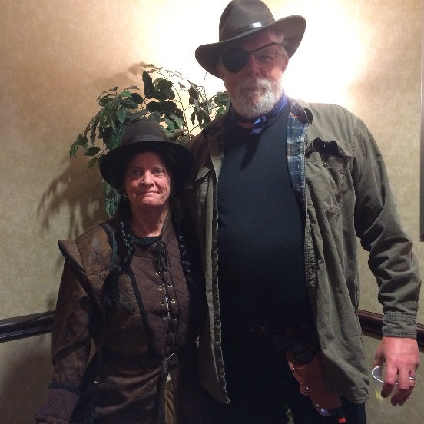
event calendar

Bob and Bonnie Krieg attending
the Spring Conference

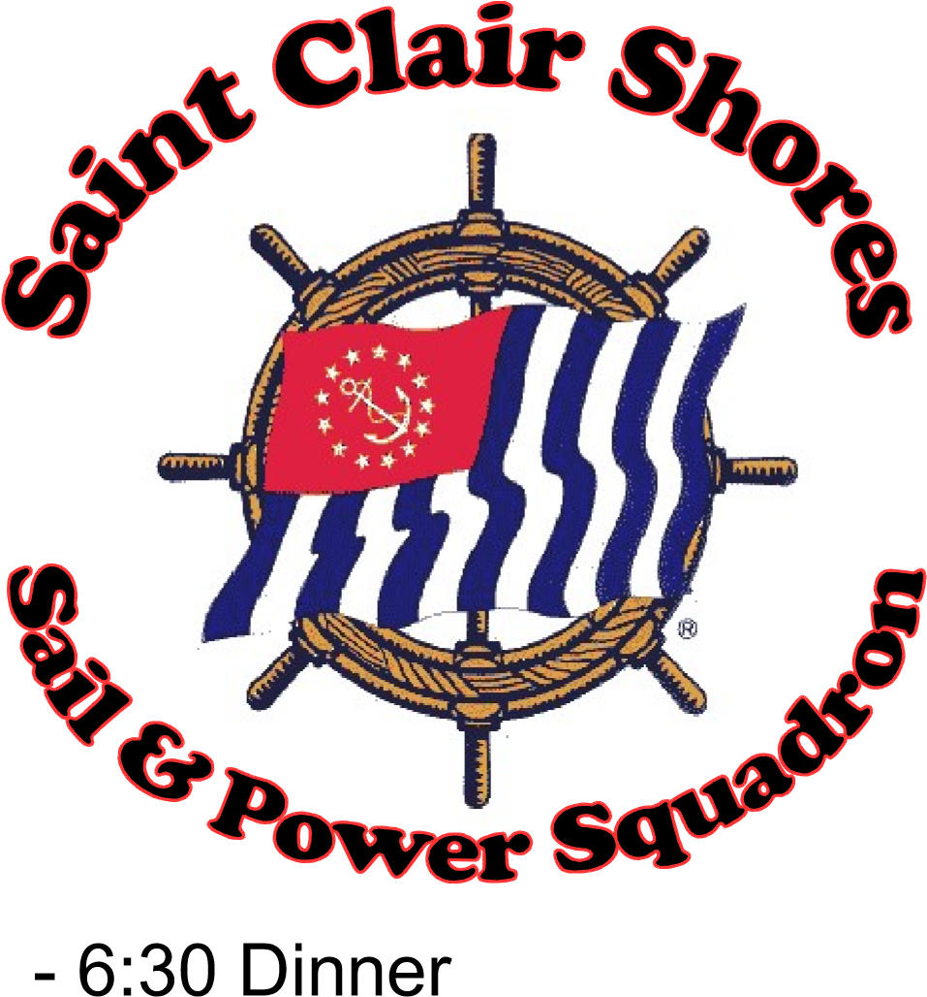

GENERAL MEMBERSHIP MEETING
AND SAFETY PICNIC
THURSDAY JUNE 1ST

- 6:30 Dinner
- 7:30 Meeting
- Members and non-members welcome
- Kids welcome (bring balls/frisbees etc.)
- Bring a dish to pass
- Hot dogs provided by SCSSPS
- Exhaust and deplete old signal flares
(weather permitting)
Meeting Location:
Cpl. Walter F. Bruce VFW Post 1146
28404 Jefferson Ave, St Clair Shores, MI 48081
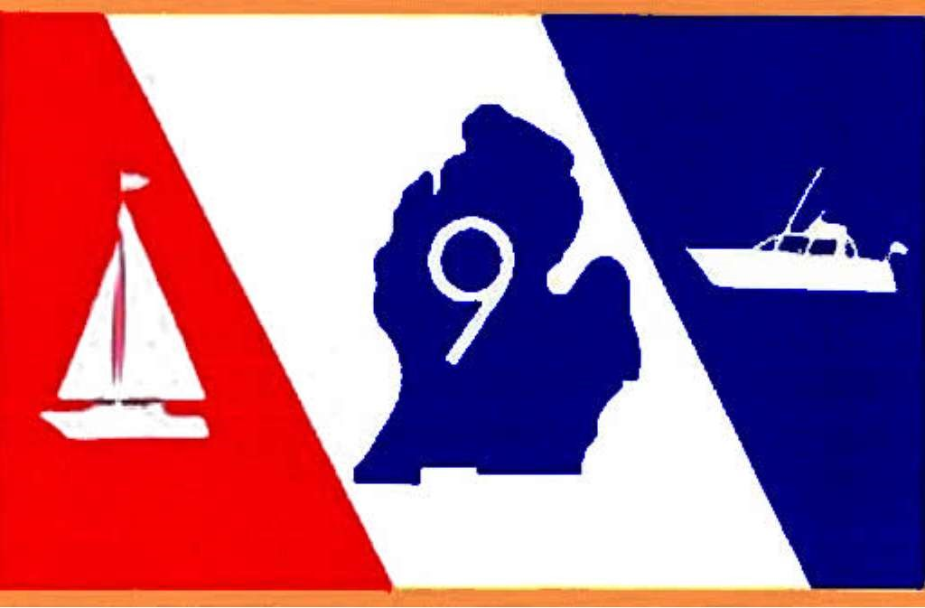
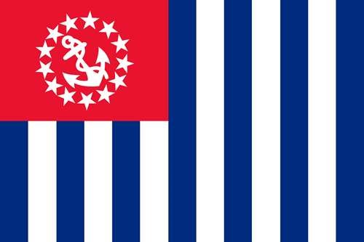
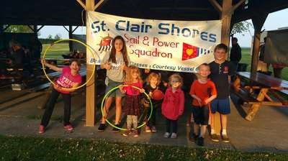
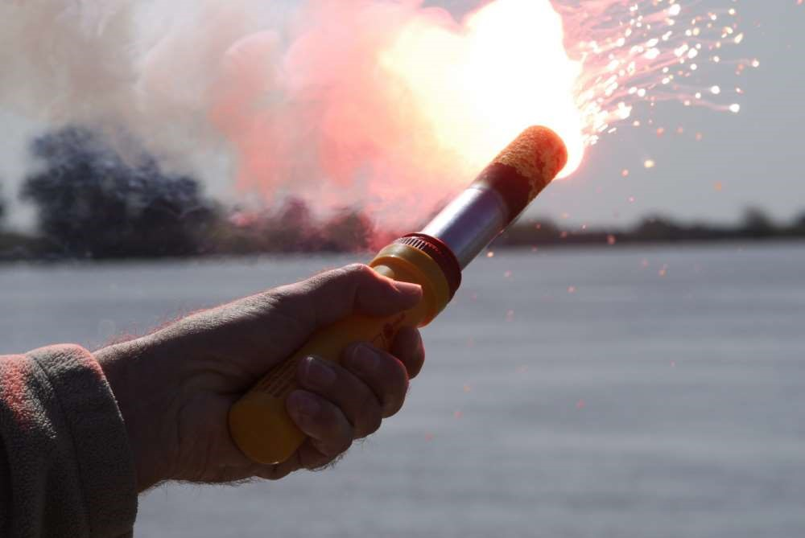

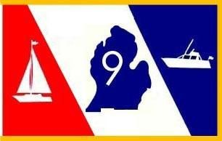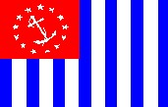

District 9 Summer 2017 Rendezvous

Location: Port Huron’s Be a Tourist in our Town Weekend June 2 – 4

FRIDAY EVENING – 6 PM - BBQ picnic dinner at the Marina Pavilion; BBQ pulled pork, BBQ pulled chicken, variety of grilled sausages, homemade baked beans, cole slaw, Greek pasta salad and cookies for dessert. Bring your beverage of choice to enjoy with your meal. - $10 per person

SATURDAY MORNING – 8 – 10 AM - Pancake Breakfast to start the day for the group before you enjoy your day in Port Huron; $6 per person
Join Us!

SATURDAY EVENING – 6:30 PM = Catered dinner; Chicken Marcella, Wild Rice,
Sliced Roast Beef with Au Jus, Baby Red Skins, Homemade Macaroni and Cheese,
Seasonal Steamed Vegetables, Bread and Roll Basket, Tossed Salad, Michigan
Cherry Salad, Fresh Veggie Pasta Salad, Fresh Seasonal Fruit Trays, Assorted Specialty Desserts, Coffee, Ice Tea, and Lemonade; $28 per person

SUNDAY MORNING – Bon Voyage 8 – 9 AM Muffins, Petite Danish, coffee/tea and juice; $5 per person

In addition to special events, Port Huron has a host of attractions to enjoy:

∙ The Great Lakes Maritime Center, home of the BoatNerd.com website.
∙ The Huron Lightship, retired in 1970, the last lightship on the Great Lakes.
∙ The Fort Gratiot Lighthouse, first in Michigan and second oldest on the Lakes.

YOU CAN MAKE BOAT WELL RESERVATIONS NOW:

Reservation contact: John Haley 810-919-5719; e-mail jhaley@umflint.edu

Coordinators:
Denise Samu; denisesamu@comcast.net – 586-665-7611
Teena Lashbrook; teenalashbrook@hotmail.com

Local Hotels

Shuttles Running throughout Port Huron during their Be a Tourist in our Town weekend

Holiday Inn Express |  |  | Fairfield Inn
2021 Water St. |  |  | 1635 Yeager Street
Port Huron, MI 48060 |  |  | Port Huron, MI 48060
810-662-3400 |  |  | 810- 982-8500
Comfort Inn |  |  | Main Street Lodge and Suites
1700 Yeager St |  |  | 514 Huron Avenue
Port Huron, MI |  |  | Port Huron, MI 48060
810-982-5500 |  |  | 810-824-4042
Best Western |  |  | Days Inn, Port Huron
2282 Water St |  |  | 2908 Pine Grove
Port Huron, MI 48060 |  |  | Port Huron, MI 48060
810-987-1600 |  |  | 844-249-7539
Hampton Inn |  |  | Quality Inn Suites
1655 Yeager St |  |  | 800 Hancock
Port Huron, MI 48060 |  |  | Port Huron, MI 48060
810-966-9000 |  |  | 810-997-5999

Double Tree
800 Harker St
Port Huron, MI 48060
810-984-8000

D9 USPS Port Huron Rendezvous – June 2-3-4

Mail to: Lucrecia Ferriby, 6680 Holverson, Carsonville, MI 48419-9491
Or email completed form to: bumpyrockroad@yahoo.com
Rank Last Name First Name Grade

_____ _____________________________ __________________________________ _________
_____ _____________________________ __________________________________ _________
_____ _____________________________ __________________________________ _________
_____ _____________________________ __________________________________ _________
Address: ___________________________________________________ City: _____________________________
State/Prov: ______ Zip/Postal Code: _____________Phone: ______________________

Friday Night: BBQ Dinner Provided by Squadron Members _____ (qty @ $10.00),
Saturday Breakfast _____ (qty @ $6.00)

Saturday Catered Dinner ______ (qty @$28.00) Sunday Brunch_____ (qty @ $5.00)

Make checks out to : D9 USPS Total Amount: $_______________
Kids under 8 are free! PAYMENT/RESERVATIONS NEEDED BY MAY 25TH….PLEASE MAKE YOUR RESERVATION ASAP
Contact - 586-665-7611 denisesamu@comcast.net – Denise Samu, or Teena Lashbrook, 810-434-7267 teenalashbrook@hotmail.com if you have any questions

Boating Activities 2017 D9 Squadrons
Date of Event -Also boat, car, RV identified | Brief Description April 23 update | Squadron Chair or Contact
 | Event Ideas/Additionals for 2017
 | send info to: denisesamu@comcast.net
 | Events 2017
 | D9 East Side Predicted Log, hosted by Grosse Pointe P/S. Timers & Observers welcome. 8 AM and awards lunch at 11 AM | Dale Ellis  248-583-8600
May 13 | Dearborn: Commanders Cruise on the Diamond Jack; a great cruise evening. Boarding at Bishop Park Tour Dock in Wyandotte. Check in at 1730 (5:30 PM) | Cheryl Muylaert  734-981-5191
May 13 | Anchor Bay Power Squadron Commander’s Bowling Party 4-9 p.m. at Bath City Bistro, Mt. Clemens. Pizza buffet, cash bar  Casual dress, guests welcome | Candy DeWitt 586-431-1947
June 2-3-4  Come by boat, car, RV | D9 Rendezvous - Port Huron River Street Marina,flier in progress, MARK THE DATE! Boat Well contact: Boat Well Reservation contact: John Haley 810-919-5719; e-mail jhaley@umflint.edu | Teena Lashbrooke  teenalashbrook@hotmail.com &  Denise Samu  denisesamu@comcast.net
June 16-18  Come by boat or car | Anchor Bay - St Clair - weekend activities planned including Sat dinner served at the marina, **reservations please** contact Jackie Senkmajer to be included in the group dinner! Contact St Clair Marina (810) 329-4125 for well reservations for the weekend. | Jackie or Robert Senkmajer  810-794-7527  senkmj@att.net
June 17 - Sat | Grand Traverse Bay: 2nd Annual Fresh Water Festival, at the Elk River Landing, an exciting event, come and enjoy! | Jan Hartesvelt  rosesforjanet@gmailcom
June 16 -18 | GTBay Shakedown Cruise, Elk Rapids Mi. www.gtbayboating.org | Jerry Williams jwilliams6@sbcglobal.net
June 23-25 | Toledo P/S; Port Clinton Rendezvous | Felicia or Nelson Evans
 | Joint Rendezvous with Toledo S & PS | ??
June 23-24-25  Come by boat or car | Canadian Western Ontario District Rendezvous D9: join Canadian Power and Sail Squadrons (“CPS”) for a great weekend Come by boat or car. Belle River Marina in CA. Theme: Happy 150th Birthday Canada - where your red & white! | Peter Steven-CPS; peters@uwindsor.ca  Tracie Berekoff; CPS; tberekoff@ cogeco.ca
July 12 - 14 | Anchor Bay: Put in Bay
July 14 - 16 | Toledo: Harsens Island | Larry Cole  Cell: 734-755-7252
July 14 - 16 | Detroit & Mt Clemens: St Clair Metro Park
July 22, 2017 | Anchor Bay: Boating for Vets
July 21-24 | GTBay eQuality Cruise - A tour of Grand Traverse Bay www.gtbayboating.org | Jerry Williams jwilliams6@sbcglobal.net
July 28-Aug 6  Lake Erie Rendezvous | Toledo P/S: Vermillion 28-29, Huron 30-31, Cedar Point 1-2, Kelley's Island 3rd, Port Clinton4-6th | Jan Luetz/Mary Strohmeir
July or Aug | Ann Arbor: canoe/kayak/small boat cruise event; Half Moon chain of lakes in Livingston county; details at a later date to follow | Ron Schwartz  AAPSclasses@aol.com
Aug 4 - 6 2017  Come by boat or car | D9 Picnic - Great Lakes Marina "E" Pier - Muskegeon Aug 4; day before the Annual Coast Guard Festival Parade on Aug 5 in Grand Haven, Michigan | Ralph Ziegler  989-224-7943  ralphziegler@charter.net
Aug 12  Come by boat or car | Dearborn: Annual Steak Roast (Chicken too); great event to cook your own plus great attendee donated desserts and appetizers
Aug 18 -19  Come by boat or car | D9 Lobster Bake.....in Northport. Come by car or boat. Awesome annual event fashioned after lobster bakes along the coast of Maine. A must if you are/will be in the area at this time. Many travel from far and wide to attend.Friday Cook out, Sat Breakfast, Sat dinner of Lobster/PrimeRib/Chicken all cooked outdoors. Hazerot Park, Northport, Michigan. | Donna Nelson  231-271-6968;  dbnelson4@gmail.com
Sept 8 - 10  Come by car or RV camping sight | Anchor Bay - Algonac State Park - camping at the park, come & enjoy! Did you trade your "keels for wheels"? RV sights available, come join this unique rendezvous! | Carol Gawel  carol24g@hotmail.com
Sept 8 - 10 | Toledo P/S - Put in Bay | Dan and Mary Strohmeir
 | NOTE: Toledo P/S member contact information will be added
 | after D9's Conference weekend plus list with our Squadron activities
 | as reported at Conference will also be added.

